TASK 22 :
import java.util.*;

class Solution {
public int[] finalPrices(int[] prices) {
Deque<Integer> stack = new ArrayDeque<>();
for (int i = 0; i < prices.length; ++i) {
while (!stack.isEmpty() && prices[stack.peek()] >= prices[i]) {
int idx = stack.pop();
prices[idx] -= prices[i];
}
stack.push(i);
}
return prices;
}
}

CASE 1:
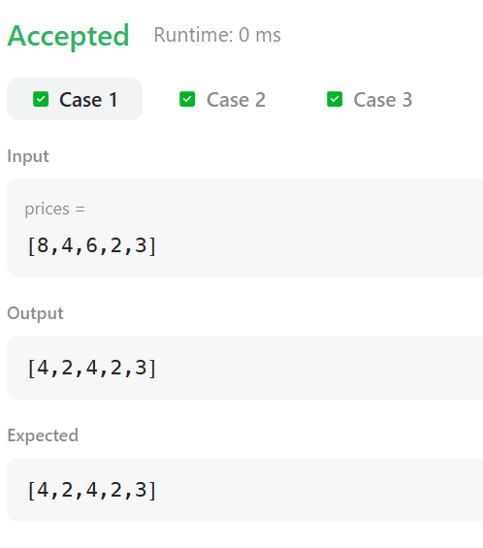
CASE 2:
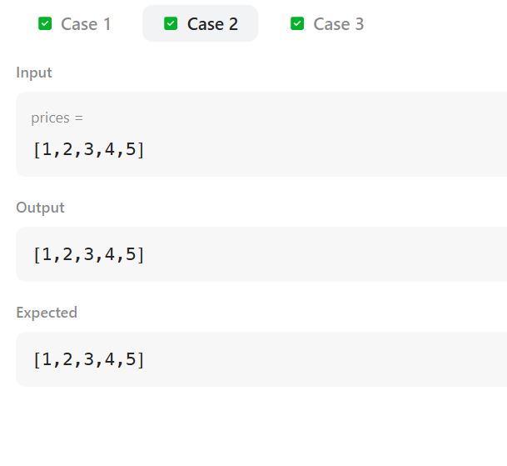
CASE 3:
